Joshua Beaver Q. Abellera

2ECE-D

Experiment 9

**Data Wrangling Using Pandas**

Assignment Screenshots

Problem 1

* *pd.merge function*

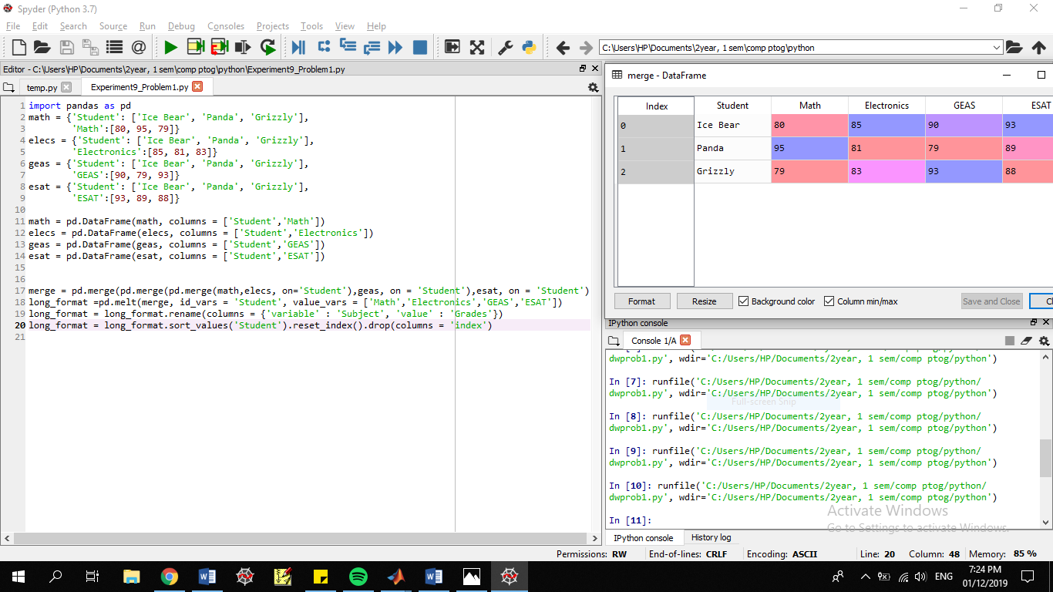

* *long format*

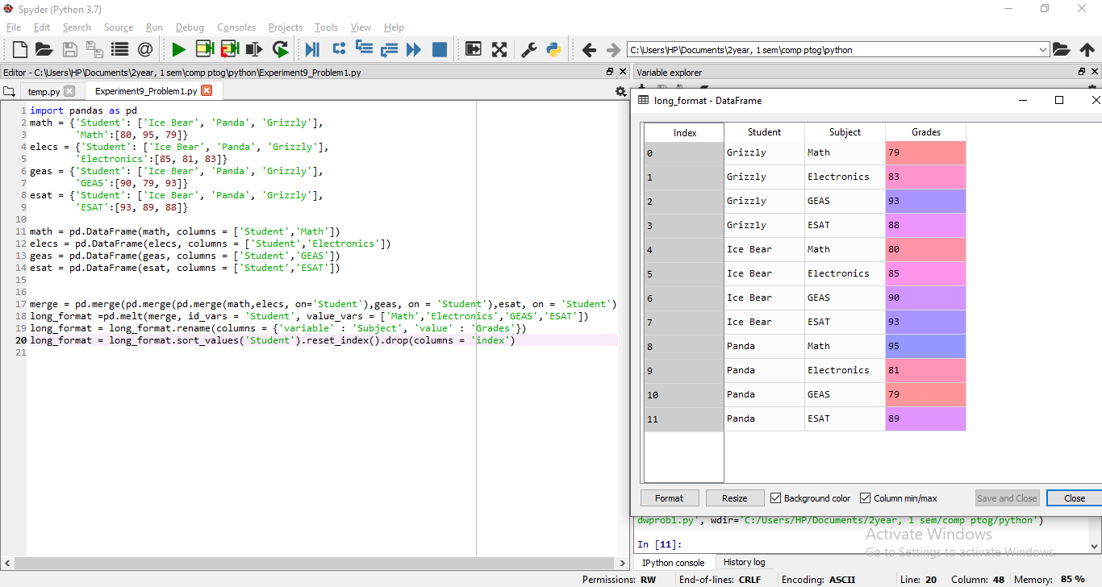

Problem 2

